THERMOGRAPHY CLINIC INC.

Cranial / Dental Health History

Name: ______________________________________________________Date of Birth______________ mm/dd/yyyy

Address: _____________________________________________________________________________

City: _____________________ State/Province: _______________ ZIP/Postal Code _______________

Telephone: Home ____________________ Work ___________________Cell ____________________

E-mail: ______________________________________________________________________________

Occupation: ____________________________ Referred By: __________________________________

What is the primary reason for this examination? _____________________________________________

Are you experiencing any of the following symptoms?

Y N Headaches
It is Dull Sharp Cluster Sinus Other

Location R L

Frontal Lobe Parietal Lobe
Temporal Lobe Occipital Lobe (rearmost part of scull)
Cerebellum 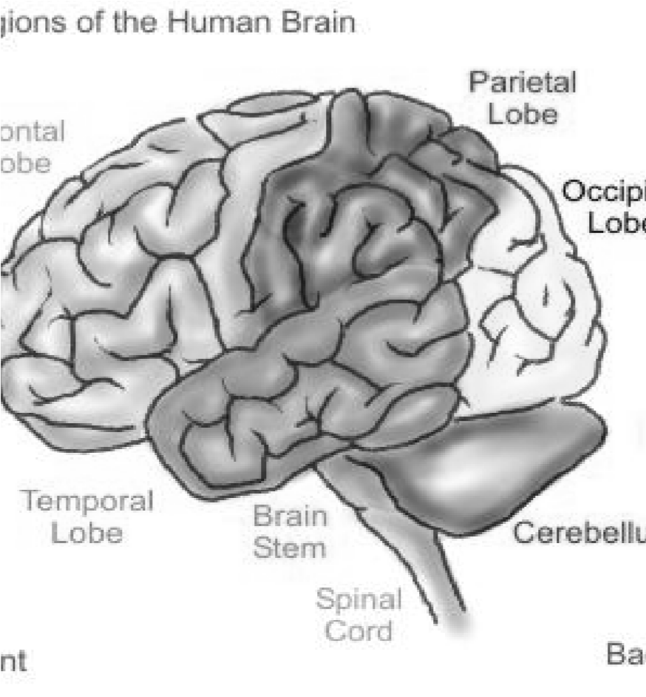

Cranial/Dental Intake 1 | P a g e
Y N Nasal Condition R L

Y N Allergies
Seasonal Hay Fever Food Dust Mold Pets Unknown

Y N Have you ever been diagnosed with Cerebral Circulatory Problems?
Please explain: ____________________________________________________________

Y N Have you been Diagnosed with Thyroid condition?
Hypo Hyper Hashimoto’s Grave’s Goiter Cancer Unknown

Y N Other Conditions ___________________________________________________________

Y N Do you have a specific dental problem?
Describe: _________________________________________________________________

Y N Do you have dental examinations on a routine basis? Date of Last Visit: ______________
mm/dd/yyyy

Please indicate if you have any of the following conditions?

Y N Have you ever been diagnosed with TMJ? Temporomandibular Joint Disorder

Y N Root Canal Treatments Upper Left Upper Right
Lower Left Lower Right
Y N Do your gums ever bleed?

Y N Do you clench or grind your teeth

Y N Does your jaw hurt or click? R L

Y N Do you have any difficulty chewing?

Y N Do you think you have active decay or gum disease

Please note any other concerns/issues you may have: __________________________________________

_____________________________________________________________________________________
General Health Information

Y N Do you have any medical complaints or conditions? Please explain ___________________
_________________________________________________________________________

Y N Are you currently taking any medications? Please list ______________________________ _________________________________________________________________________
Cranial/Dental Intake 2 | P a g e

